Crayon Batik Indian Tapestry

Designed by Karen Stubblefield

Adapted from <http://taylortinkerings.com/CrayonBatik.html> 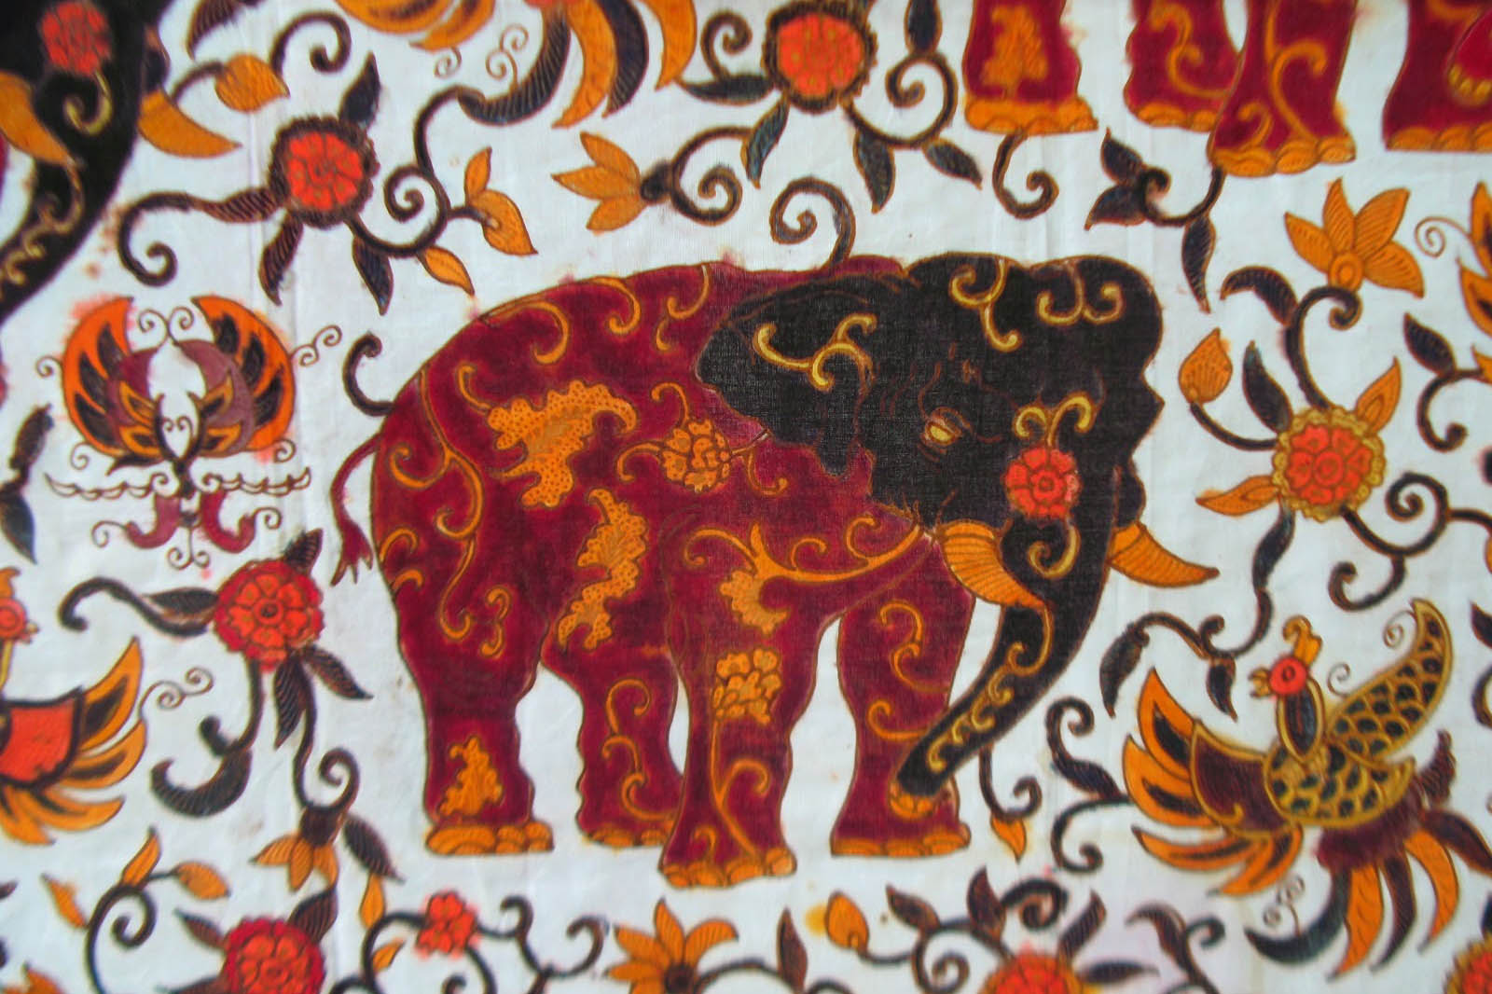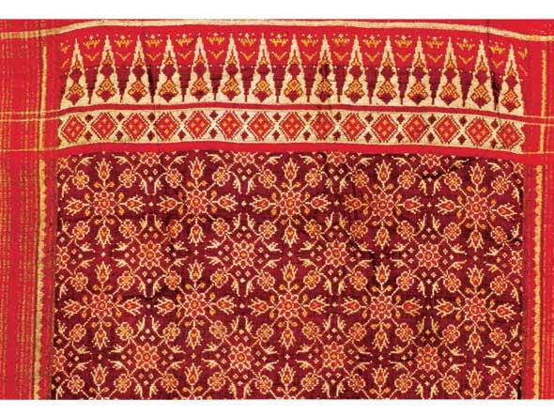

History and image: <https://www.utsavpedia.com/motifs-embroideries/batik-a-worldwide-art/>

# OVERVIEW & PURPOSE

Students will explore use of organic and geometric shapes through a crayon batik activity that recreates traditional Indian batik cloth tapestries. The history of batik tapestries will be introduced and students will create their own version using the crayon batik technique. They will review warm/cool colors and distinguish between geometric and organic shapes during this process.

# EDUCATION STANDARDS

**1.1** use a variety of materials and media (crayon, acrylic wash, paper) to produce different visual effects (batik)

**2.4** explore use of shape and forms in 2D works (geometric and organic)

**8.3** create works inspired by cultural styles

# OBJECTIVES

1. Learn about the history of Indian batik fabric
2. Identify and define organic and geometric shapes
3. Create our own batik cloth using organic and geometric shapes

# MATERIALS NEEDED

1. crayons
2. Manila paper
3. Black acrylic paint diluted with water
4. Large flat paint brushes
5. Table covers

# ACTIVITY

*Describe activity that will reinforce the lesson*

Day 1

1. Introduce Indian batik with PPT
2. Review geometric and organic shapes
3. Have students volunteer to draw geometric and organic shapes on whiteboard
4. Provide students with scrap paper; have them create a T-Chart and label one side geometric and one side organic.
5. Students will be asked to provide at least 4 for each side of the T-Chart
6. When they have completed the T-Chart (make sure they have teacher approval), they will begin their black crayon outline of their batik tapestry.
7. **Students will create a GEOMETRIC border!! The border will enclose ORGANIC shapes (look at exemplar)--they should work on this for the remainder of class.**
8. Double check to see students are following expectations and doing a geometric border and organic main composition.

Day 2

1. Students should finish their black outlines if they have not already. If they are done, they may start coloring in their outlines.
2. Demo to students how to press down hard (but not so hard that the crayons snap) so there is ideally no paper showing through--the best method would be to hold the crayon toward the portion touching the paper--holding it too far back is unstable and will cause snappage. This will be important for an successful batik effect.

Day 3

1. Continue coloring if necessary, all students should be done coloring today.
2. When all students are done, instruct them to gently crumple up their crayon drawings. Make sure they don’t squeeze too hard or the paper will rip.
3. Have them carefully un-crumple their drawing and flatten it as much as possible with their hands.
4. Provide diluted black acrylic paint (one squirt + about ¼ cup of water, mixed well) for them to brush over their wrinkled crayon drawing.
   * **Make sure students blot the excess diluted paint with a paper towel so the paper does not get drenched.**
5. Lay the drawings to dry, by next class it will show the batiked effect

