Ansel Adams and Christa Rijneveld Landscapes

Designed by Karen Stubblefield

Ansel Adams, *Mt. McKinley and Wonder Lake* Christa Rejnavik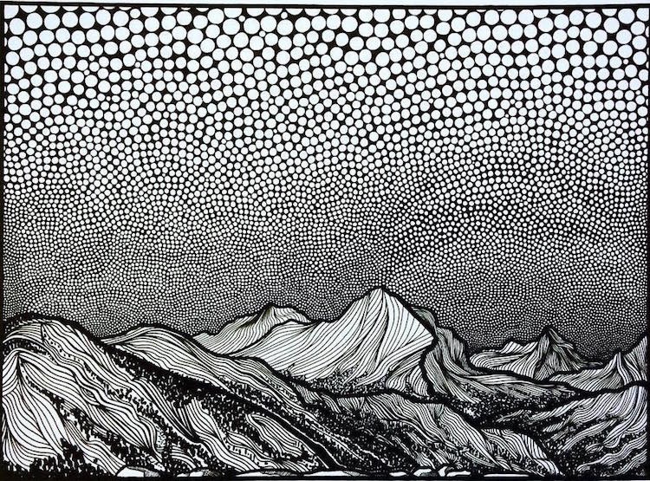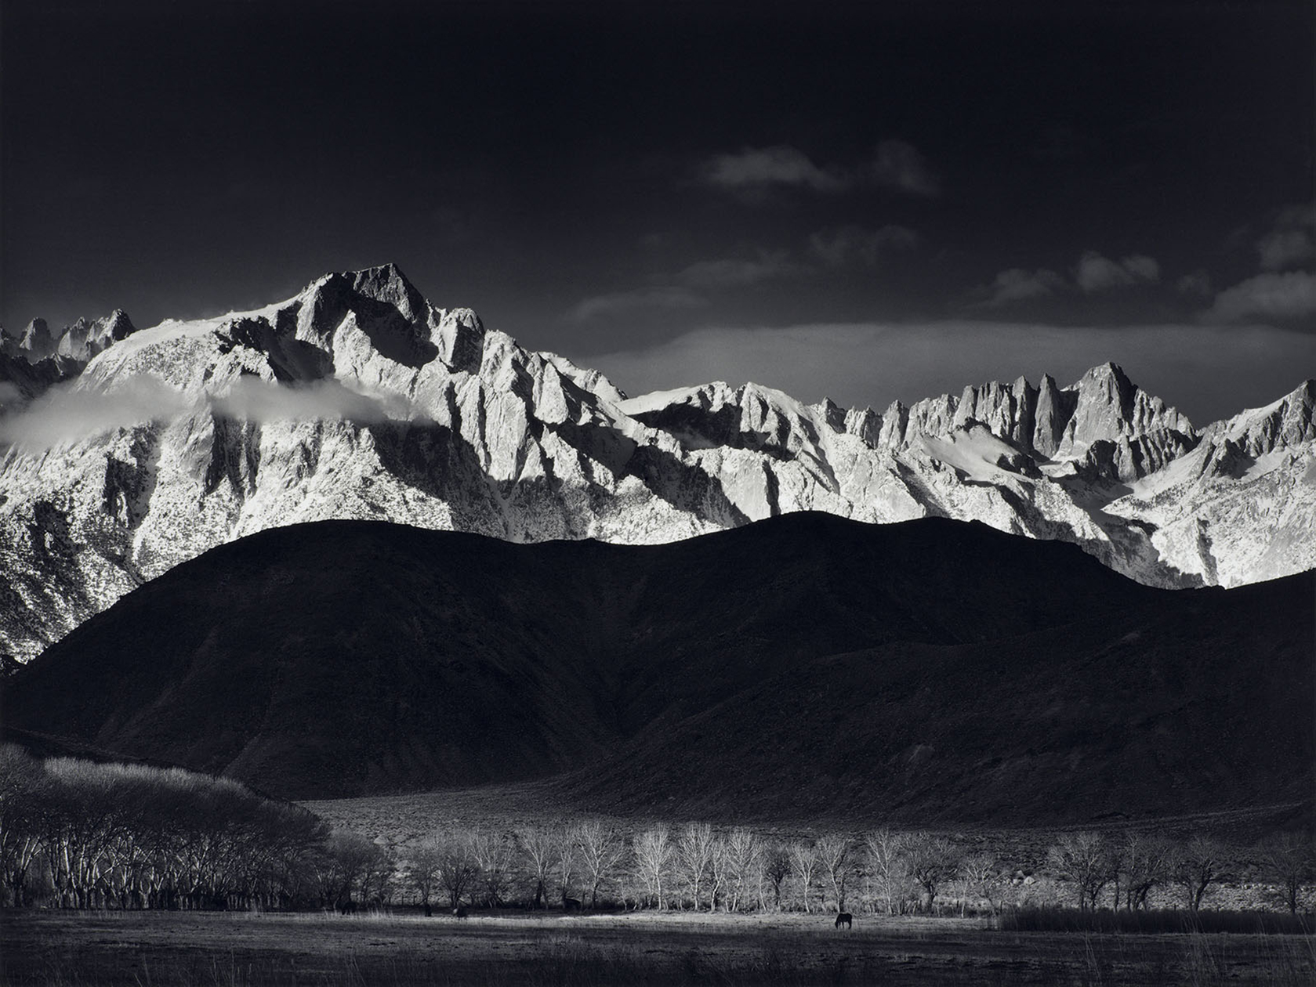

# OVERVIEW & PURPOSE

Students will learn about photographer Ansel Adams and his contribution to environmentalism (especially the Sierra Club and “protecting wild spaces”). Using Adams as a springboard, students will then examine the works of contemporary artist Christa Rijneveld and her mountainscape line drawings. Students will then pick an existing mountain range and recreate the image in black and white line drawings. Focus will be on line variety and understanding foreground, midground, and background.

# TIMEFRAME

Lesson will take 2-3 class periods.

# EDUCATION STANDARDS

**2.2** Explore the use of line in 2D works; identify a wide variety of lies i n the environment and in artwork (curved, straight, thick, and thin).

**5.3** Describe similarities and difference in works, and present personal responses to the subject matter and use of design elements.

**6.1** Ask and answer questions regarding artwork (“What is the artist trying to say?” “Who made this, and why?” “How does this work make me feel?”)

# OBJECTIVES

1. Learn about photographer Ansel Adams and his contribution to environmentalism.
2. Compare Adams’ photos with artist Christa Rijneveld’s drawings.
3. Identify a variety of lines and discuss foreground, midground, and background.
4. Select an existing mountain range and create a line drawing using black ink and marker.

# ESSENTIAL QUESTIONS

* How can an artist use his or her art to create change in society?

# GUIDING QUESTIONS

* Can you compare and contrast the two artists’ works?
* What visual effects can you use to show foreground, midground, and background?

# VERIFICATION

*Steps to check for student understanding*

1. SWBAT compare and contrast artworks by historical and contemporary artists.
2. SWBAT plan their design prior to the final process.
3. SWBAT identify the basics of landscape composition.
4. SWBAT use a controlled hand to create uniform lines.
5. SWBAT apply a pattern to the background.
6. SWBAT apply a monochromatic color scheme.

Elementary Visual Art Rubric

|  |  |  |  |  |
| --- | --- | --- | --- | --- |
|  | Master  4 | Skilled  3 | Apprentice  2 | Beginner  1 |
| **Concept Application** | Lesson objectives were completely met. | Lesson objectives were mostly met. | Lesson objectives were partially met. | Lesson objectives were not met; student did not create an artwork. |
| **Variation of Elements** | Student went above and beyond the application expectations for learned elements and principles of design. | Student showed application of learned elements and principles of design. | Student showed minimal application of learned elements and principles of design. | Student did not apply the learned elements and principles of design. |
| **Material Usage** | Student followed appropriate expectations for materials. | Student mostly followed appropriate expectations for materials. | Student occasionally did not follow appropriate expectations for materials. | Student did not follow appropriate expectations for materials; lost art privileges. |
| **Conduct** | Student is always on task. | Student needed minimal reminder to stay on task. | Student needed moderate reminders to stay on task. | Student needed constant reminders to stay on task. |

# ROUTINES

* Meet and greet on rug
* Introduce lesson
* Show Powerpoint/other resources if needed
* Ask students to share expectations and objectives before going to seats
* **Always have students write their names on their paper before continuing**, check this step since there are so many kids (500 in a week), artwork will get lost if unnamed.
* Review material usage
* Clean up 5 minutes before class end unless:
  + If there is a story, have students clean up 15 minutes prior to accommodate the book.
* Walk students out, give verbal reminder of next week’s goals.

# ACTIVITY

*Describe activity that will reinforce the lesson*

Day 1

1. Introduce Ansel Adams Powerpoint
2. Have students compare and contrast the Adams and Rijneveld’s works.
3. Review basics of landscape composition.
4. Students will select from a collection of mountain ranges (teacher will supply printed copies for each table)
5. Have students use sketch paper to practice outlining their selection.
6. When they feel confident, they may receive a large drawing paper and thin black marker to begin their drawing.

Day 2

1. Review artists and landscape composition.
2. Students should have at least started their marker drawings. If not, remind them to begin.
3. Ideally drawings will be completed by end of class.

Day 3

1. Review objectives and expectations.
2. Students may use half of class to finish their drawings if necessary.
3. Students will begin adding their monochromatic colors.
4. We will conduct a Gallery Walk when all works are done and do a TAG review using art words (that means, no “This is good” “I think it looks nice”) to describe and explain their answers .
   1. **TAG** stands for:
      1. **T**ell something you like
      2. **A**sk a question about the artwork
      3. **G**ive a suggestion

# VOCABULARY

* Photographer
* **Environmentalist**-a person who is concerned with or advocates the protection of the environment.
* **Advocate** - someone who publicly supports an issue.

# RESOURCES

Christa Rijneveld. Untitled. Retrieved from <https://mymodernmet.com/line-drawings-of-mountains-christa-rijneveld/>

Ansel Adams Sierra Club. Retrieved from: <https://www.sierraclub.org/library/ansel-adams>

Exemplar:

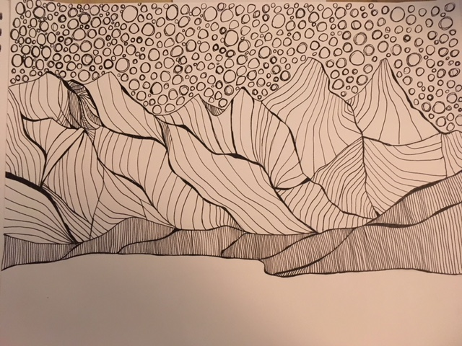

# MATERIALS NEEDED

1. Thin black pen (Sharpie or Micron)
2. Medium drawing paper
3. Scrap paper for sketch
4. Printouts of mountain ranges in US