Johannes Itten Fragmented Shapes

Designed by Karen Stubblefield

Johannes Itten, *Farbformen and Struktuten*, goauche, 1953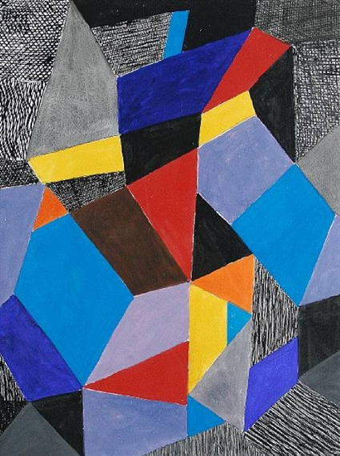

<http://www.worqx.com/color/itten.htm>

# OVERVIEW & PURPOSE

Students will explore geometry and shapes through Bauhaus artist Johannes Itten’s artworks, applying concepts of primary and secondary colors, specifically warm and cool hues. Use of a variety of lines will also be expected in order to create a dynamic composition.

# TIMEFRAME

2 class periods/ 3 if necessary

# EDUCATION STANDARDS

**2.2** Explore use of line in 2D works

**2.4** Explore shape and form in 2D works; identify simple shapes of different sizes

**8.3** create works inspired by a historical style

# OVERARCHING GOAL

To explore line variety and color families through the works of Johannes Itten.

# OBJECTIVES

1. Distinguish between primary and secondary colors.
2. Identify complementary colors.
3. Name and create a variety of lines.
4. Create a geometric composition showing contrast from complementary colors with accents from line variety and black and gray.

# ESSENTIAL QUESTIONS

How can we express an artistic theory in visual form?

# GUIDING QUESTIONS

* What are complementary colors?
* What are different types of lines?
* How can you use black or gray to accentuate hues?

# PERFORMANCE TASK

To show pairs of complementary colors using the artistic style of Johannes Ittens. Students should also apply line variety and review shapes.

# MOTIVATION

Johannes Itten Powerpoint and exemplar followed by class discussion of color families and line variety.

# RUBRIC/ASSESSMENT

Elementary Visual Art Rubric

|  |  |  |  |  |
| --- | --- | --- | --- | --- |
|  | Master  4 | Skilled  3 | Apprentice  2 | Beginner  1 |
| **Concept Application** | Lesson objectives were completely met. | Lesson objectives were mostly met. | Lesson objectives were partially met. | Lesson objectives were not met; student did not create an artwork. |
| **Variation of Elements** | Student went above and beyond the application expectations for learned elements and principles of design. | Student showed application of learned elements and principles of design. | Student showed minimal application of learned elements and principles of design. | Student did not apply the learned elements and principles of design. |
| **Material Usage** | Student followed appropriate expectations for materials. | Student mostly followed appropriate expectations for materials. | Student occasionally did not follow appropriate expectations for materials. | Student did not follow appropriate expectations for materials; lost art privileges. |
| **Participation** | Student is always on task. | Student needed minimal reminder to stay on task. | Student needed moderate reminders to stay on task. | Student needed constant reminders to stay on task. |

# INSTRUCTIONAL APPROACHES

**Art history**- learn about importance of Bauhaus artist Johannes Itten and his contribution to modern color theory.

**Constructivist-** students will create their own composition with shapes formed by intersecting lines, color theory, and line variety.

# MATERIALS

1. Oil pastels (students may also use crayon or color pencil)
2. 11” x 14” drawing paper (smaller size will work as well)
3. 12” rulers
4. Pencils
5. Thin black ink pens

VOCABULARY

* Variety
* Bauhaus
* Complementary colors

# ACTIVITY

*Describe activity that will reinforce the lesson*

**Day 1**

1. Learn about artist Johannes Itten and his contribution to color theory.
2. Ask students what colors they see in Itten’s works. Follow with what lines and shapes are visible.
3. Review primary and secondary colors.
4. Introduce complementary colors with Itten’s color wheel. Emphasize how contrast is created with complementary colors.
5. Demo pencil and ruler portion. Emphasize large shapes (at least 7) and holding the ruler firmly in the middle so it doesn’t slide around.
   1. After you make a combination of horizontal, vertical, and diagonal lines to make large shapes (emphasize *direction* of lines), show how to fill in
6. Provide students with blank white drawing paper, pencils, and ruler. (make sure names are written on back corner).
7. When students are satisfied with their pencil lines, they may trace over them with a black pen or thin black Sharpie.

**Day 3**

1. Review line variety, student should refer to their worksheet at their tables.
2. Students will begin adding at least 3 different types of lines in the shapes created last week (demo for students)--emphasize using controlled movements versus scribbling for a more cohesive effect.

**Day 4**

1. Review last week’s lines.
2. Re-introduce complementary colors, students should refer to worksheets at table.
3. Provide students with oil pastels. **They are to pick only 2 sets of complementary colors to add on their picture** (ie. blue and orange, purple and yellow)
4. Make sure students have the complementary colors side by side (demo for students)
5. Students may use black and gray in their compositions but the majority must be the complementary colors.
6. Show proper usage of pastels (blending).