Gee’s Bend Quilt

Designed by Karen Stubblefield

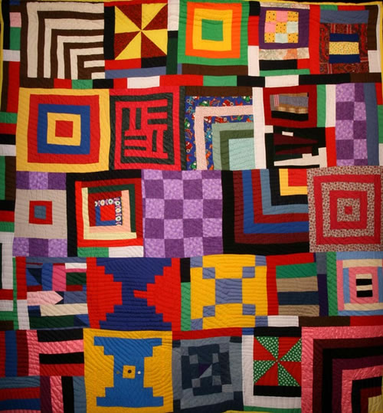

Retrieved from <https://static.wixstatic.com/media/1597d9_21a72d8b8cfe4c83829cb0bf984625a8~mv2.jpg>

# OVERVIEW & PURPOSE

Students will explore the significance of quilts made by women in Gee’s Bend, Alabama in African American history through visual aids and poetry. Using multicolor paper, students will create quilt squares showing complementary colors and geometric shapes. The lesson will be followed up with the story *Stitchin’ and Pullin’: A Gee’s Bend Quilt*.

# EDUCATION STANDARDS

**1.2** Create artwork in a variety of 2D media (paper assemblage with glue)

**2.1** For color, explore effects of complementary colors (for kindergarten, warm and cool colors)

**2.4** Explore geometric shapes

# OBJECTIVES

1. Discuss the quilters and their quilts of Gee’s Bend and their contribution to the civil rights movement.
2. Review geometric shapes.
3. Introduce complementary colors (or warm/cool colors)
4. Create unique paper quilt square designs using a combination of complementary colors and geometric shapes.

# MATERIALS NEEDED

1. Construction paper in complementary colors: purple, yellow, red, green, blue, orange cut into 6” x 6” pieces
2. Pre-cut patterned paper, 6” x 6”
3. Glue bottles
4. Scissors

# RUBRIC/ASSESSMENT

Elementary Visual Art Rubric

|  |  |  |  |  |
| --- | --- | --- | --- | --- |
|  | Master  4 | Skilled  3 | Apprentice  2 | Beginner  1 |
| **Concept Application** | Lesson objectives were completely met. Student created 2 complete quilt squares that demonstrate application of complementary colors or warm and cool colors. Shows use of geometric shapes. | Lesson objectives were mostly met. Student created 2 quilt squares but did not demonstrate correct use of complementary colors or warm and cool colors on both. Shows use of geometric shapes. | Lesson objectives were partially met. Student only completed 1 quilt square; did not demonstrate correct use of complementary colors or warm and cool colors. Did not show use of geometric shapes. | Lesson objectives were not met; student did not create an artwork. |
| **Variation of Elements** | Student went above and beyond the application expectations for learned elements and principles of design. Student demonstrates ability to create 2-3 geometric shapes and distinguish between warm and cool or complementary colors. | Student showed application of learned elements and principles of design. Student was able to create 1-2 geometric shapes or distinguish between warm and cool or complementary colors. | Student showed minimal application of learned elements and principles of design. Student was unable to distinguish between warm and cool or complementary colors; was able to create 1 geometric shape. | Student did not apply the learned elements and principles of design. |
| **Material Usage** | Student followed appropriate expectations for materials. | Student mostly followed appropriate expectations for materials. | Student occasionally did not follow appropriate expectations for materials. | Student did not follow appropriate expectations for materials; lost art privileges. |
| **Participation** | Student is always on task. | Student needed minimal reminders to stay on task. | Student needed moderate reminders to stay on task. | Student needed constant reminders to stay on task. |

# INSTRUCTIONAL APPROACHES

**Art History-** introduces an American folk art that coincides with the Civil Rights Movement

**Constructivist-** how to create geometric shapes out of one existing shape and arrange them into a composition.

# ACTIVITY

*Describe activity that will reinforce the lesson*

Day 1

1. Introduce YouTube video: <https://www.youtube.com/watch?v=EqhueIb9TnA> (The Quilters of Gee’s Bend) start at 3:19.
2. Review geometric shapes
3. Inform students they will be making 2 quilt squares
4. Teacher demo of quilt square:
   1. Make sure students pick two colors that are in specific groups (red/green, yellow/purple, blue/orange) + one patterned paper (for Kindergarten, sort paper bins into warm and cool colors)
   2. Select one color to be the “base” of the quilt square. Cut the other paper into medium size geometric shapes.
   3. As you cut the shapes, ask students what shape they are.
   4. Glue them onto the uncut color.
   5. Accent quilt square with the patterned paper.
   6. Inform students when they are done, they may make another quilt square using another pair of colors.
5. Dismiss students by table color to retrieve paper materials. Reinforce writing names on their uncut paper.
6. End class 12-15 minutes early to accommodate clean up and meeting on rug.
7. Read a poem or two from *Stitchin’ and Pullin: A Gee’s Bend Quilt*
8. Dismiss class

Day 2

1. Review expectations for lesson (pick 2 sets of colors)
2. Review geometric shapes
3. Students may continue working on their quilt square. They should start the 2nd square if they have not already.
4. Students are expected to finish both by end of class.
5. End class 12-15 minutes early to meet on rug for class discussion. Pull up exemplars to show.
6. Ask guiding questions:
   1. What do you notice about the colors?
   2. Do they seem to pop out more? Or do they seem to fade?
7. Introduce complementary colors and their purpose in art (to accentuate colors on opposite sides of the color wheel)
8. If there is time, read a poem from *Stitchin’ and Pullin: A Gee’s Bend Quilt*

Day 3

* Have students finish their quilt squares if they are still unfinished, this should be the last day to complete the assignment.