Romare Bearden Collage

Designed by Karen Stubblefield

Romare Bearden, *Jazz Village* 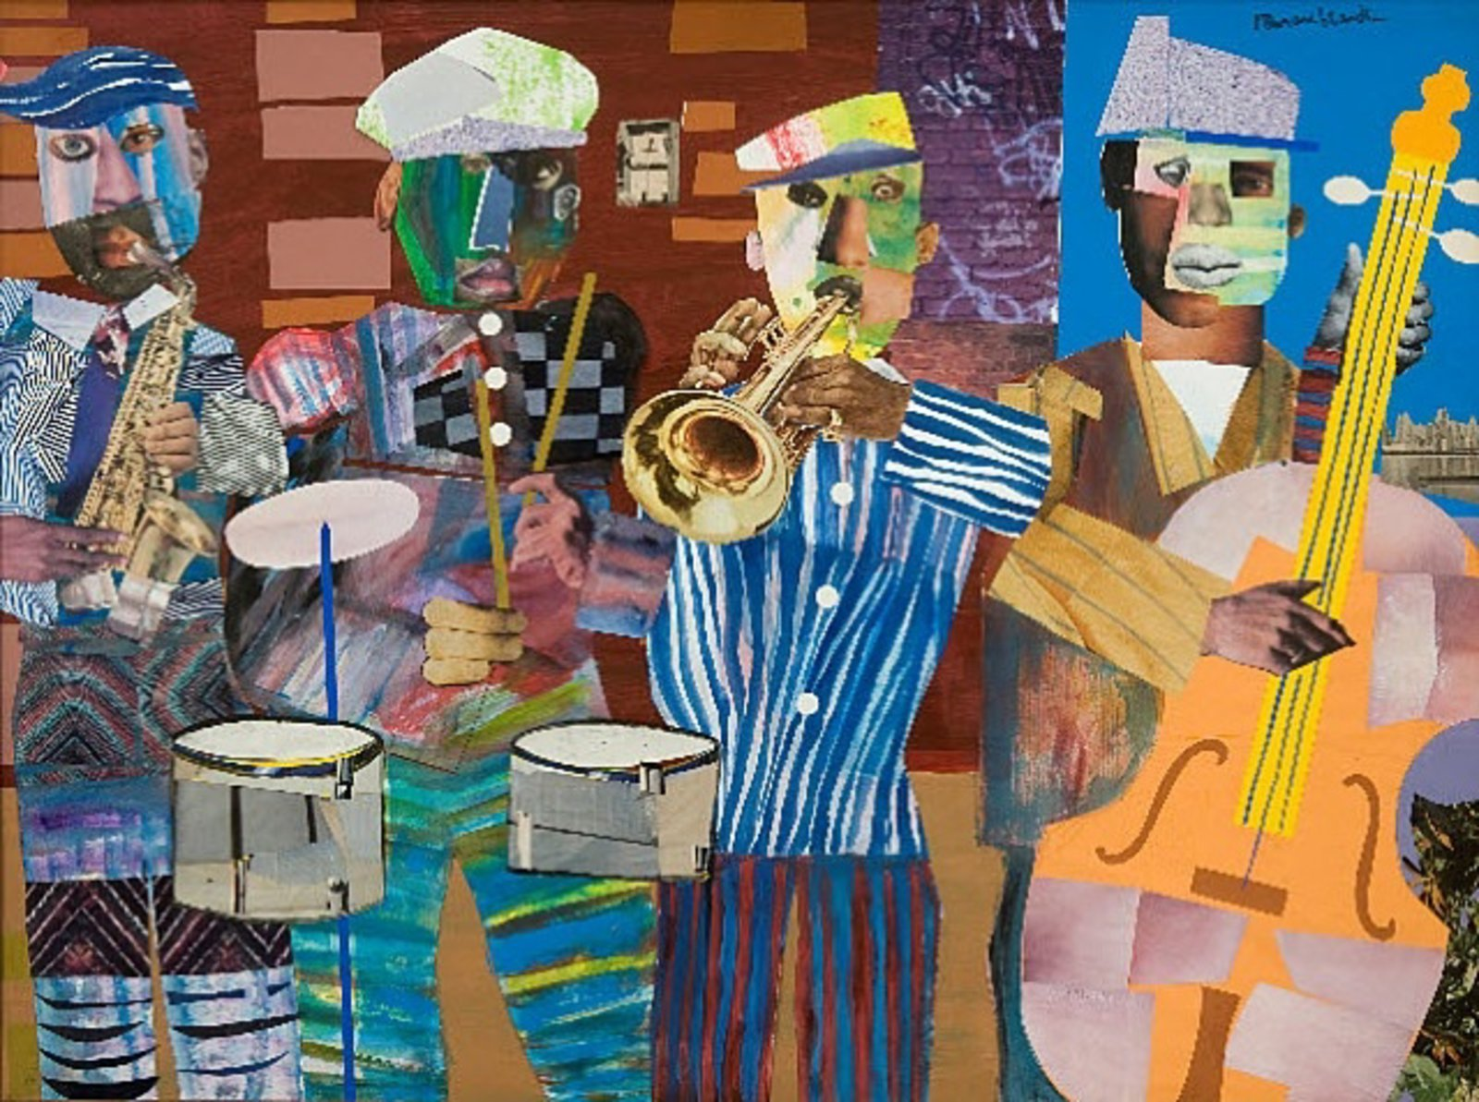

# OVERVIEW & PURPOSE

Students will learn about African American artist Romare Bearden and his vibrant collages detailing his daily life and experiences (read *My Hands Sing the Blues*). While listening to Jazz music, students will create a composition that shows rhythm and variety through use of line, shape, and color. There will be emphasis on improvisation and spontaneity through mark-making. The lesson will culminate in making a stamp showing figures in motion (dancing to the jazz music) that will be superimposed on the initial composition.

# TIMEFRAME

The lesson will take 3 class periods (50 min each).

# EDUCATION STANDARDS

**1.1** use variety of materials and media

**2.3** explore use of textures in 2D works

**2.6** define and identify instances of rhythm and variety

# OVERARCHING GOAL

To demonstrate an artistic style based on a historically significant artist, conceptualize one art form into another (music to visual art), and experiment with new artmaking methods.

# OBJECTIVES

1. Learn about artist Romare Bearden and his artwork.
2. Convey improvisation and spontaneity through line, shape, and color.
3. Explore how to create a sense of movement with figure study.

# ESSENTIAL QUESTIONS

* How can we transform an idea into visual form?

# GUIDING QUESTIONS

* If a line can dance, how would it dance to this music?
* What shapes/lines/texture can you use to show rhythm?
* What variety of shapes/lines/texture can you create?

# KNOWLEDGE AND SKILLS

1. SWBAT identify rhythm and variety in an artwork.
2. SWBAT use line, shape, and texture to create rhythm and variety in their own artwork.
3. SWBAT use a variety of methods and materials to achieve different visual effects.

# PERFORMANCE TASK

After learning about artist Romare Bearden, students will be tasked with making a visual interpretation of jazz music. Students are expected to use line, shape, and texture to create a sense of rhythm and variety.

# MOTIVATION

* Romare Bearden Powerpoint
* Practice creating lines/shapes/texture to jazz music

# RUBRIC/ASSESSMENT

Elementary Visual Art Rubric

|  |  |  |  |  |
| --- | --- | --- | --- | --- |
|  | Master  4 | Skilled  3 | Apprentice  2 | Beginner  1 |
| **Concept Application** | Lesson objectives were completely met. Student successfully expressed abstraction of music into visual form. | Lesson objectives were mostly met. Student mostly expressed abstraction of music into visual form. | Lesson objectives were partially met. Student somewhat expressed abstraction of music into visual form. | Lesson objectives were not met; student did not create an artwork. |
| **Variation of Elements** | Student went above and beyond the application expectations for learned elements and principles of design. Final artwork shows strong evidence of rhythm and variety through color, line, and shape arrangement. | Student showed application of learned elements and principles of design. Final artwork shows some evidence of rhythm and variety through color, line, and shape arrangement. | Student showed minimal application of learned elements and principles of design. Final artwork shows barely any evidence of rhythm and variety through color, line, and shape arrangement. | Student did not apply the learned elements and principles of design. Did not produce a final artwork. |
| **Material Usage** | Student followed appropriate expectations for materials. | Student mostly followed appropriate expectations for materials. | Student occasionally did not follow appropriate expectations for materials. | Student did not follow appropriate expectations for materials; lost art privileges. |
| **Conduct** | Student is always on task. | Student needed minimal reminders to stay on task. | Student needed moderate reminders to stay on task. | Student needed constant reminders to stay on task. As a result, final artwork was incomplete. |

# 

# ROUTINES

* Meet and greet on rug
* Introduce lesson
* Show Powerpoint/other resources if needed
* Ask students to share expectations and objectives before going to seats
* **Always have students write their names on their paper before continuing**, check this step since there are so many kids (500 in a week), artwork will get lost if unnamed.
* Review material usage
* Clean up 5 minutes before class end unless:
  + If there is a story, have students clean up 15 minutes prior to accommodate the book.
* Walk students out, give verbal reminder of next week’s goals.

# INSTRUCTIONAL APPROACHES

**Art History**- learning about an important figure in African American art

**Constructivist-** translating music into visual form; using elements of art to create a symbol to represent an idea.

# MATERIALS NEEDED

1. Watercolor paper
2. Multicolor construction paper
3. Scissors
4. Black tempera paint
5. Large paint brushes
6. 5 large cups to hold paint
7. Multicolor tissue paper
8. White oil pastels
9. Leftover printed paper from previous lesson (Paul Klee self-portraits)

For stamps:

1. Glue
2. Foam shapes
3. Cardboard squares
4. Wooden manikin

# VOCABULARY

* Collage
* Rhythm
* Variety
* Texture
* Improvisation
* Jazz

# ACTIVITY

*Describe activity that will reinforce the lesson*

Day 1

1. Introduce lesson with Romare Bearden Powerpoint
2. Discuss rhythm and variety and how you could use line, shape, and texture to convey these elements.
3. Have students come up and draw examples on the board.
4. Point out how Bearden was inspired by jazz music and “translated” what he heard into visual form. We are going to “hear” with our eyes and capture the rhythm onto paper.
5. Teacher demo:
   1. Play series of jazz music
   2. Follow the sounds with different lines and express with shapes
6. Provide students with scrap paper and pencil to practice their visual interpretations of music.
   1. Play a series of different types of jazz music, keep it on loop.
   2. Encourage students to follow the music with their pencil and scrap paper with each set of music (this should take 5 minutes)
7. Halfway through class allow students who feel confident with their sketching to retrieve drawing paper and a white oil pastel. Make sure students write their names on the back of their paper.
8. With 15 minutes left, have students clear their areas and meet on the rug for *My Hands Play the Blues: Romare Bearden’s Childhood Journey* until end of class.

Day 2

1. Review objectives and expectations.
2. Introduce tissue paper bleeding and relate back to rhythm and variety (arrangement of shapes from cut or torn pieces of paper + color variety)
3. Teacher demo:
   1. Lay small piece (about 2” x 2”) of tissue paper on oil pastel paper.
   2. Dampen brush, remove excess water, and dab brush atop tissue paper until completely covered.
   3. Encourage color variety and shapes.
4. Allow students who have not completed the white oil pastel + paper to do so (keep jazz music on repeat in background)
5. Students who are done may retrieve tissue paper, water bucket, and large paintbrush.
6. All students should be done with tissue paper bleeding portion have them placed on the drying rack.
7. With 15 minutes left, begin clean up routine and meet up on rug to continue *My Hands Play the Blues: Romare Bearden’s Childhood Journey.*

Day 3

* Review objectives and expectations
* Make connection between rhythm, variety and movement.
* Teacher demo of movement figure stamps using manikin:
  + Arrange wooden manikin into a dancing pose
  + On small square of cardboard arrange foam shapes to emulate pose on mankin (cut foam into smaller pieces if necessary)
  + Keeping the arrangement intact, remove a foam piece, apply glue onto cardboard where the foam piece lay, then replace the foam piece; repeat until all shapes are glued down. Allow to dry.
  + When glue is dry and foam pieces are secure, brush black tempera paint onto the foam pieces then stamp onto a contrasting piece of construction paper firmly so that all the paint transfers. Slowly remove the stamp to reveal the print.
* Provide students with foam stamp materials and manikin; have them recreate stamp craft portion.
* While the stamp dries, teacher will demo how to paint and print their stamp.
  + Use large brush
  + Since we are just using black paint, water cups will be unnecessary
  + Do not overly saturate brush with paint (show students how to wipe off excess on side of paint cup)
  + Brush the foam figure completely until no color shows.
  + While the paint is still wet, gently pick up your stamp by the sides of the cardboard and press firmly on the construction paper.
  + Slowly lift to reveal the print.
  + Trim an outline around the print to further accentuate sense of movement.
* Students will remove tissue paper flakes from their drawings. Students can place the tissue paper into a bin for future use. If stamps are still drying, students may begin cutting the leftover printed paper from previous Paul Klee lesson.
* Students can be called up by table to retrieve paintbrushes, placemat, and colorful paper.
  + Have students choose from a selection of pre-cut colorful papers to stamp on.
  + They can choose up to 3 pieces of paper.
* Instruct students to stamp on their selected papers.
* After they stamp, have students trim an outline around their print as modeled making sure to leave margin around their print.